Steam Games Analysis
Made By
Name: Moataz Nasser
Group: C

Dataset
Dataset used: Steam games Dataset 2025
Link: https://www.kaggle.com/datasets/srgiomanhes/steam-games-dataset-2025

Data Cleaning
- Dropped additional_content column as it was not needed by using the df.drop() function.
- Fixed a problem where some release_dates also included time of day by using df.replace().
- Split release_dates into 3 columns which are year, month, and day by using dt.year, dt.month, and dt.day and assigned appropriate data types to them.
- Exploded the columns “Categories”, and “Genres” for easier analysis using df.explode().
- Removed missing values from columns “Categories”, and “Genres” while analyzing them.
- Turned column “platform” into 3 dummy columns for easier analysis by using df.get_dummies().

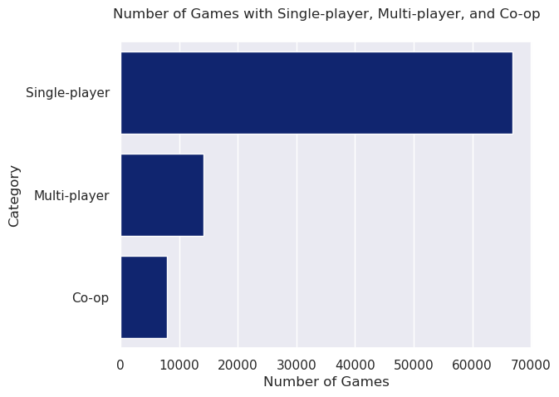
Visualizations
Bar chart to show the number of games on Steam that support single player, multiplayer, and co-op modes.
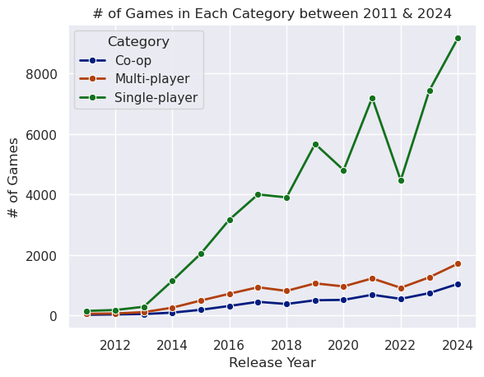
Multi-line chart showing the number of games on steam that supports the different game modes over the years between 2011 and 2024.

Word Cloud showing the most common genres for steam games.

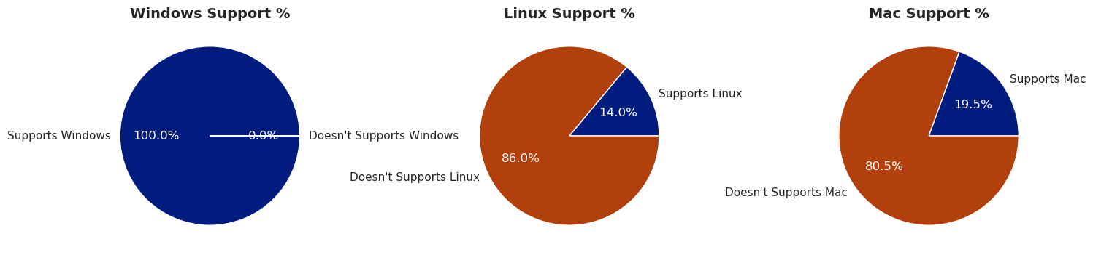
Pie charts showing the proportion of games on Steam that support different operating systems (Windows, Linux, and Mac).
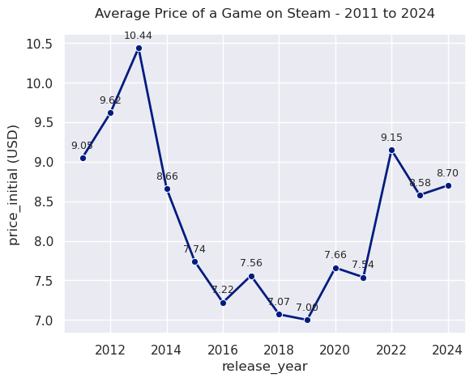
Line chart showing the average price of a Steam game from 2011 to 2024.

